Creating Custom Image in Local Machine by Docker file and pushing it to Docker Hub Repo.

1. Creating a folder named Docker and created a Docker file and imaging it.

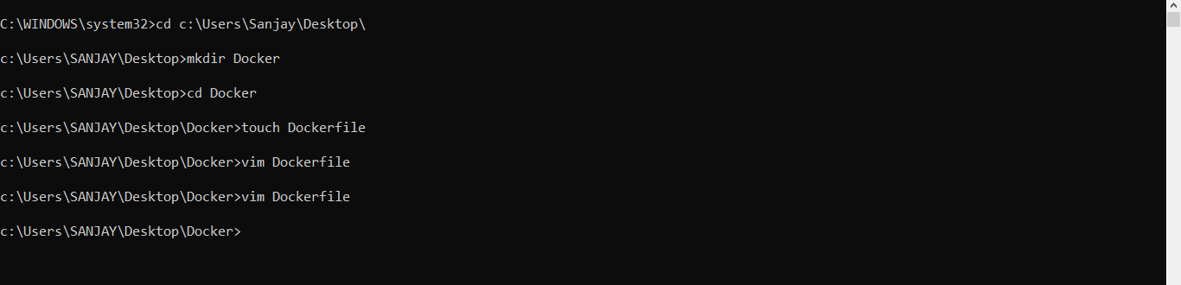

1. Providing instructions for Docker file.

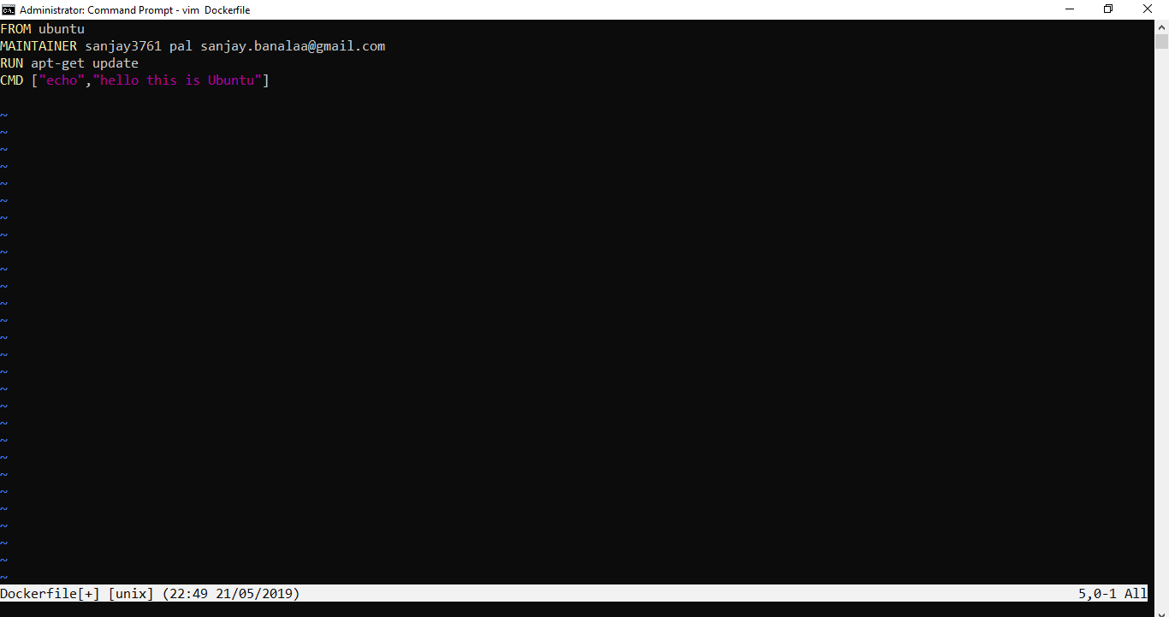

1. Generated Docker file folder in Local Machine.

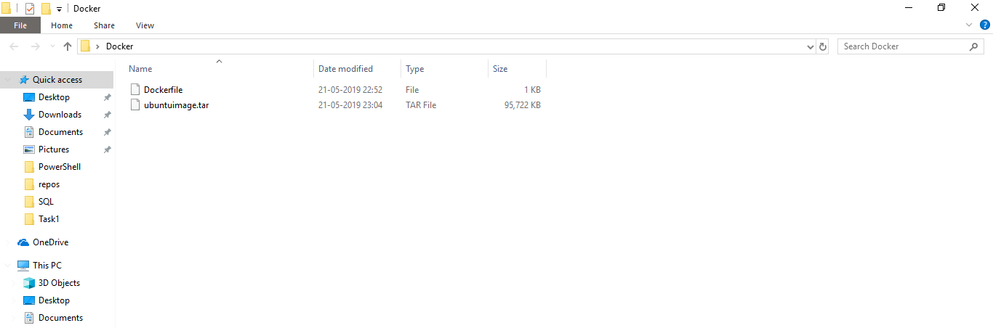

1. Building the Docker file to create an Image.

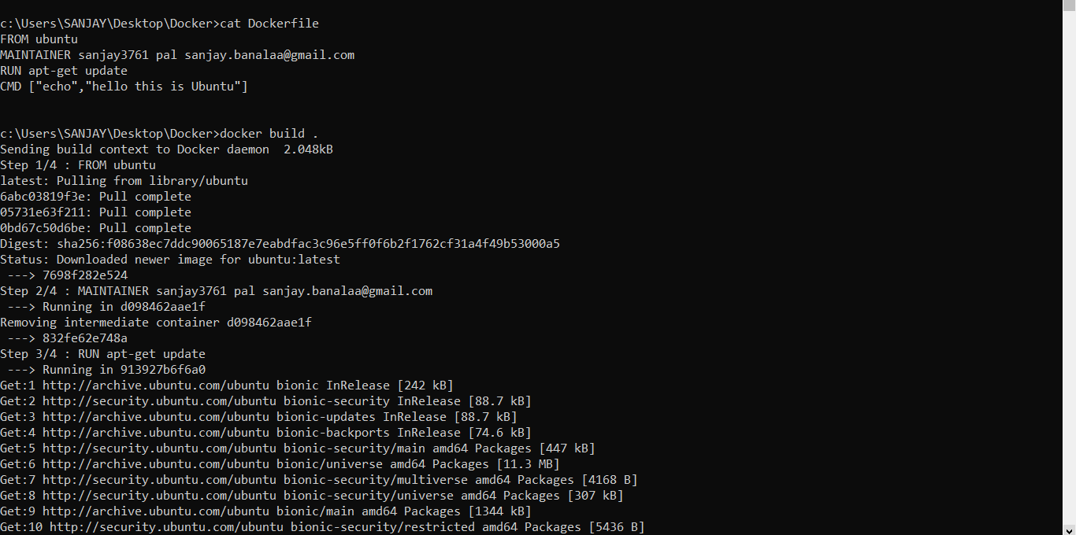

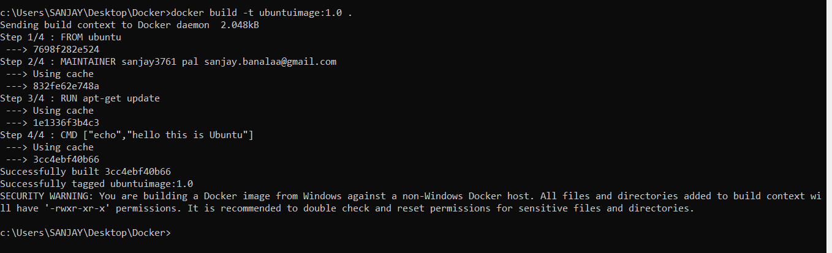

1. Checking the Image is created or not and running the image.

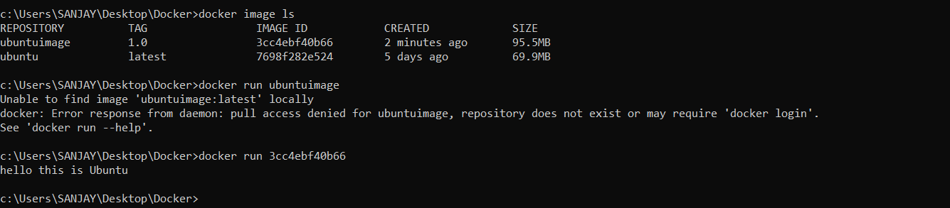

1. Creating Docker Repository in Docker Hub.

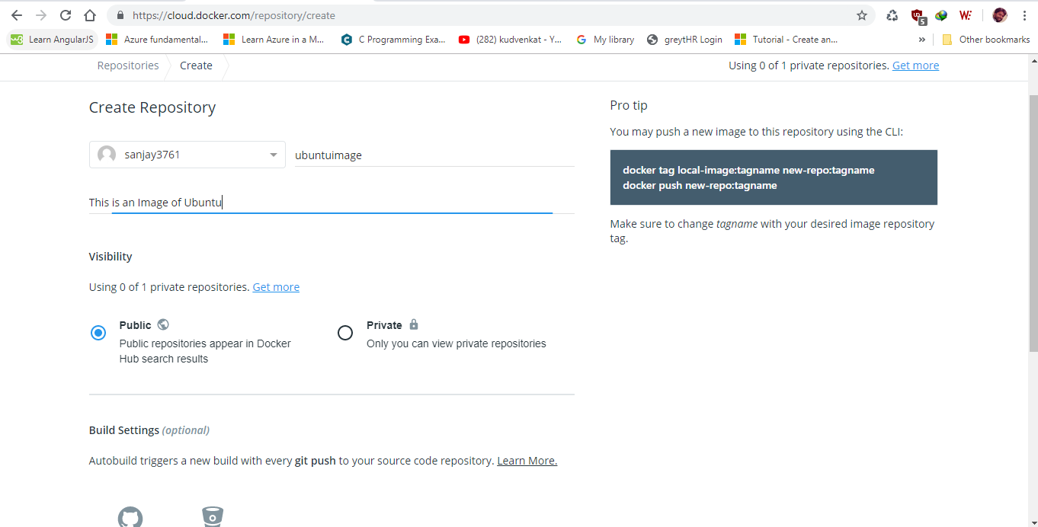

1. Pushing the Custom Image into the Docker Hub Repos.

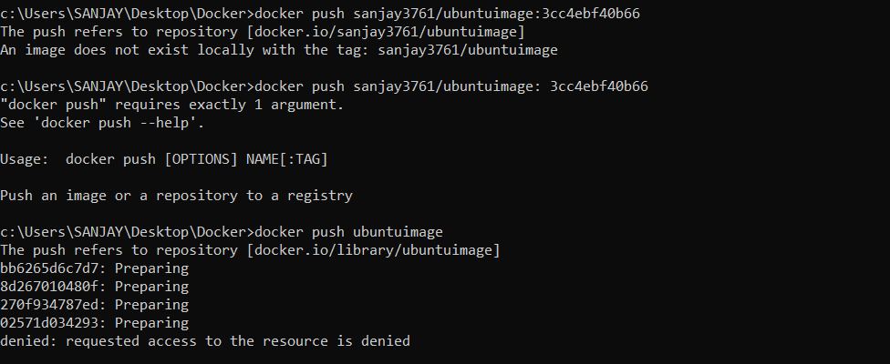

1. Saving the Image with .tar extension.

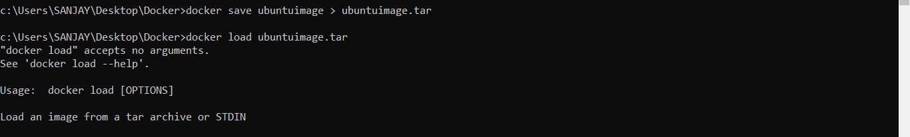

1. Loading the Image by providing input as .tar file.



1. Checking it in the Docker Hub.

